POSTMAN:

POST:

Postman POST request allows appending data to the endpoint. This is a method used to add information within the request body in the server. It is commonly used for passing delicate information.

Once we send some the request body via POST method, the API in turn yields certain information to us in Response. Thus, a POST request is always accompanied with a body in a proper format.

steps to create a POST request in Postman −

**Step 1** − Click on the **New** menu from the Postman application. The **Create New** pop-up comes up. Then, click on the Request link.

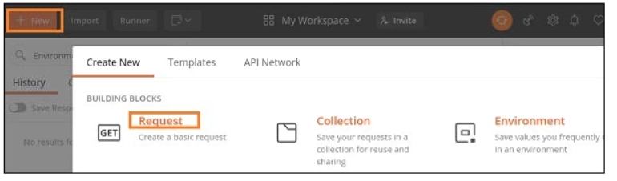

**Step 2** − **SAVE REQUEST** pop-up comes up. Enter the Request name then click on **Save**.

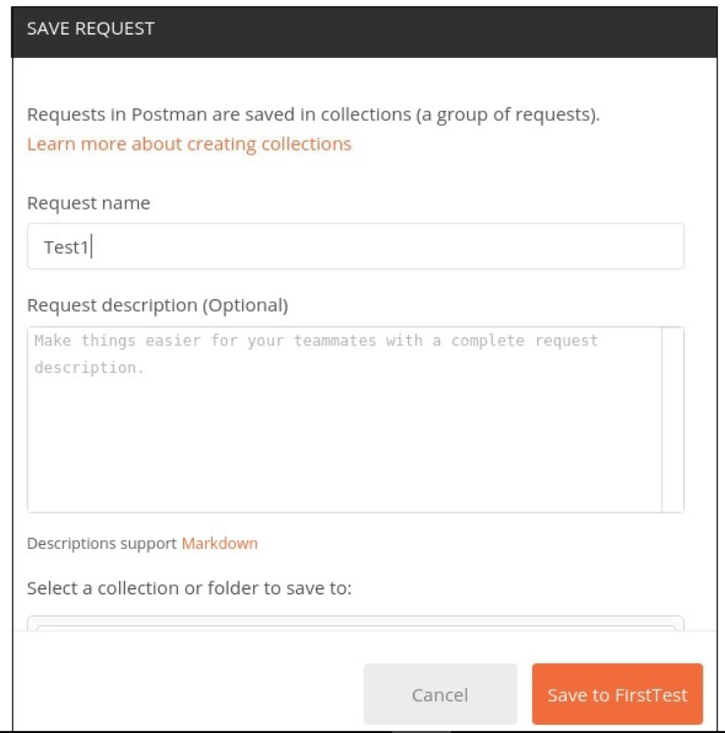

**Step 3** − The **Request name (Test1)** gets reflected on the Request tab. Also, we shall select the option **POST** from the HTTP request dropdown.

Then, enter an URL <https://jsonplaceholder.typicode.com/users> in the address bar and move to body and click raw .

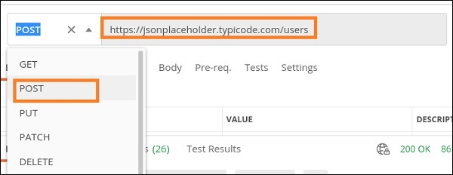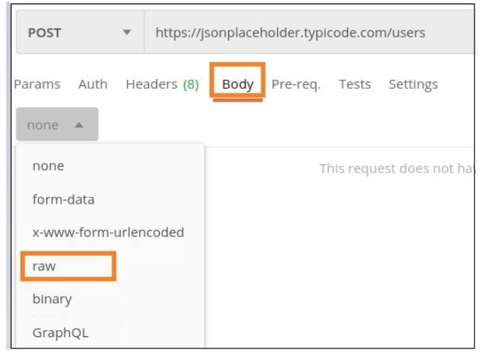

 Copy and paste the below information in the Postman Body tab.

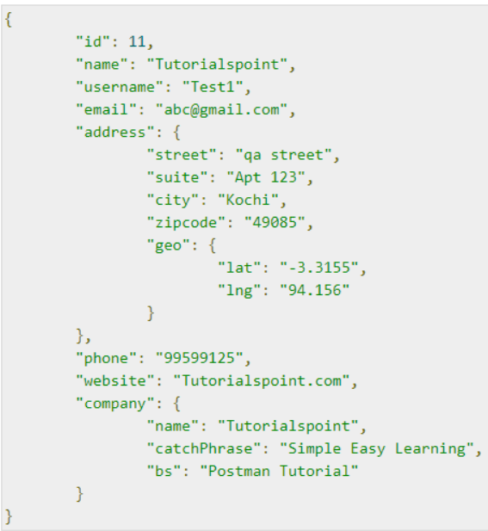

The above data that is being sent via POST method is only applicable to the endpoint: <https://jsonplaceholder.typicode.com/users>.

To pass the data in the correct JSON format, we can use the Jsonformatter available in the below link −

<https://jsonformatter.curiousconcept.com/>

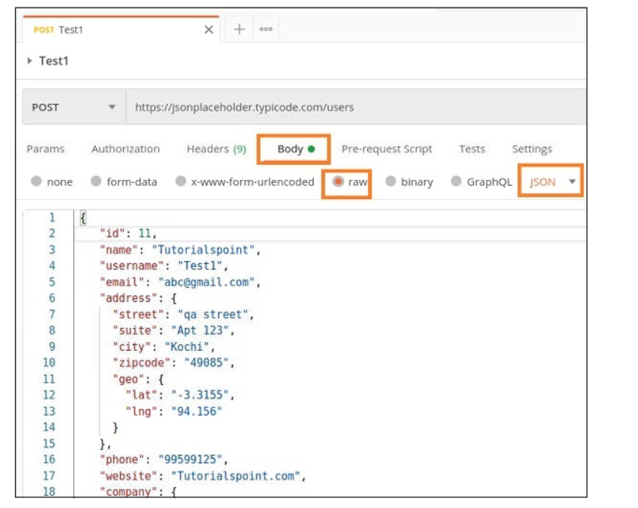

Click send. Once a request has been sent, we can see the response code 201 Created populated in the Response. This signifies a successful request and the request we have sent has been accepted by the server.

